Your Docker service needs to be active and running. You can quickly check the current status by entering the following command in your terminal:You need to Screen Capturethe output of the Docker service is active and running.Type the following command:

**docker service ps -q**

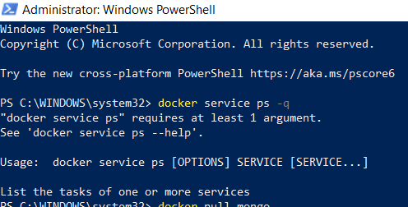

Proceed to download the latest official Docker image for the MongoDB database:You need to Screen Capturethe output

**docker pull mongo**

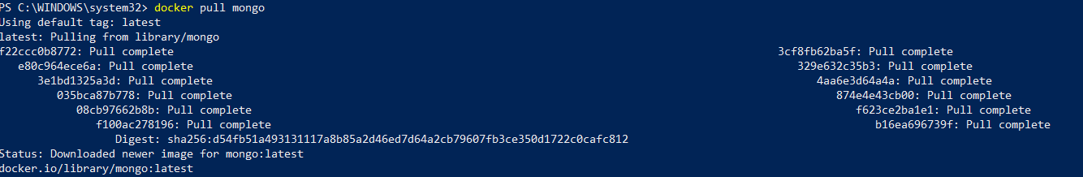

List the images in your Docker repository with the following command:You need to Screen Capturethe output

**docker images**

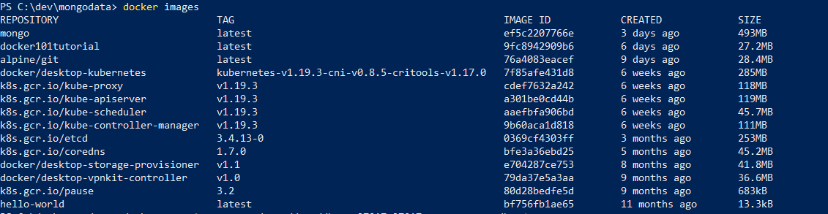

a- Create a **/mongodata**directory on the host system:  
In Winows OS:

mkdir mongodata

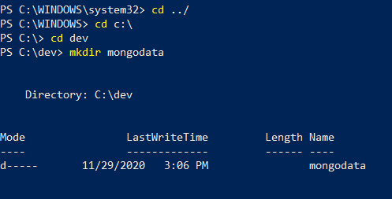

Start the Docker container with the runcommand using the mongo image. The /data/dbdirectory in the container is mounted as /mongodataon the host. Additionally, this command changes the name of the container to *mongodb*:You need to Screen Capturethe output

**docker run -dit -v mongodata:/data/db --name mongodb -d mongo**



Once the MongoDB server starts running in a container, check the status by typing:You need to Screen Capturethe output

**docker run ps**

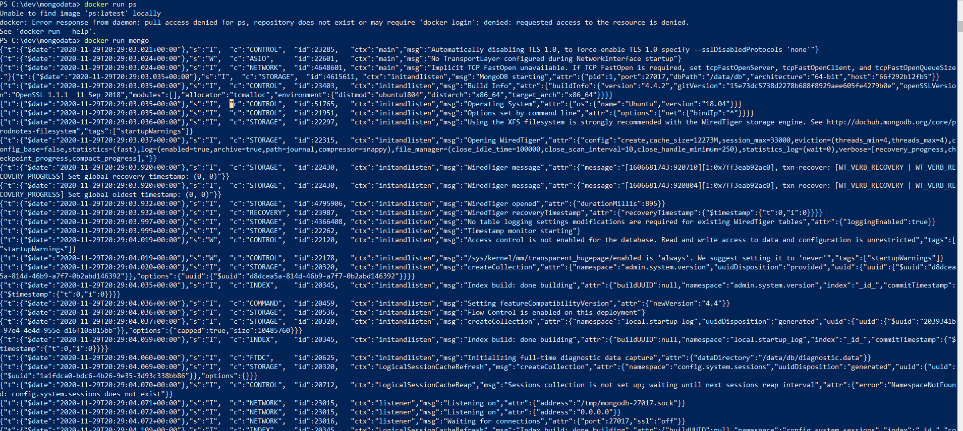

Optionally you can specify the MongoDB port explicitly:  
The default port number is 27017*,*as can be seen in the output*.*  
   You need to Screen Capture the output

**docker run -it -v mongodata:/data/db -p 27017:27017 --name mongodb -d mongo**



Always check the Docker log to see the chain of events after making changes:  
   You need to Screen Capture the output  
The logs provide a wealth of useful information.

**docker logs mongodb**

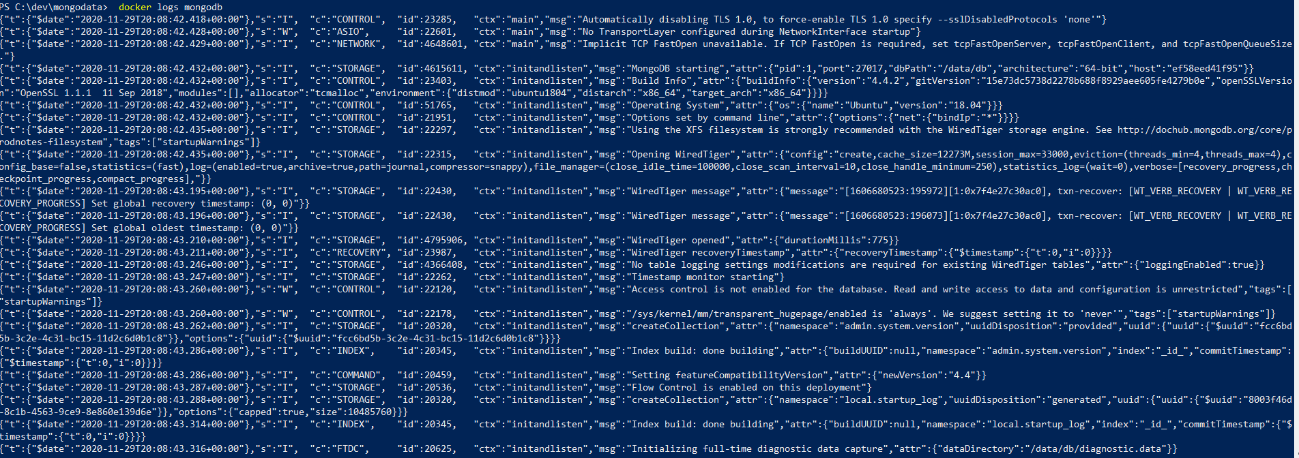

The container is currently running in a detached mode. Connect to the container using the interactive terminal instead:  
   You need to Screen Capture the output

**docker docker exec -it mongodb**

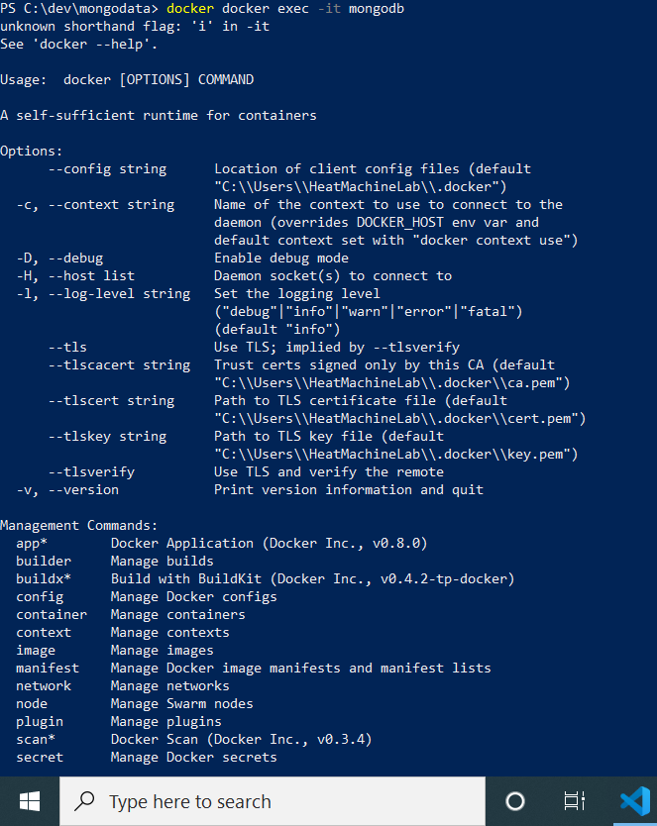

 Inspect the list of running Docker containers by typing:

### You need to **Screen Capture** the output

**docker ps**

The **docker stop** command is a short and clear command that [stops running container instances](https://phoenixnap.com/kb/how-to-list-start-stop-docker-containers):

 (Links to an external site.)

### You need to **Screen Capture** the output

**docker stop mongodb**

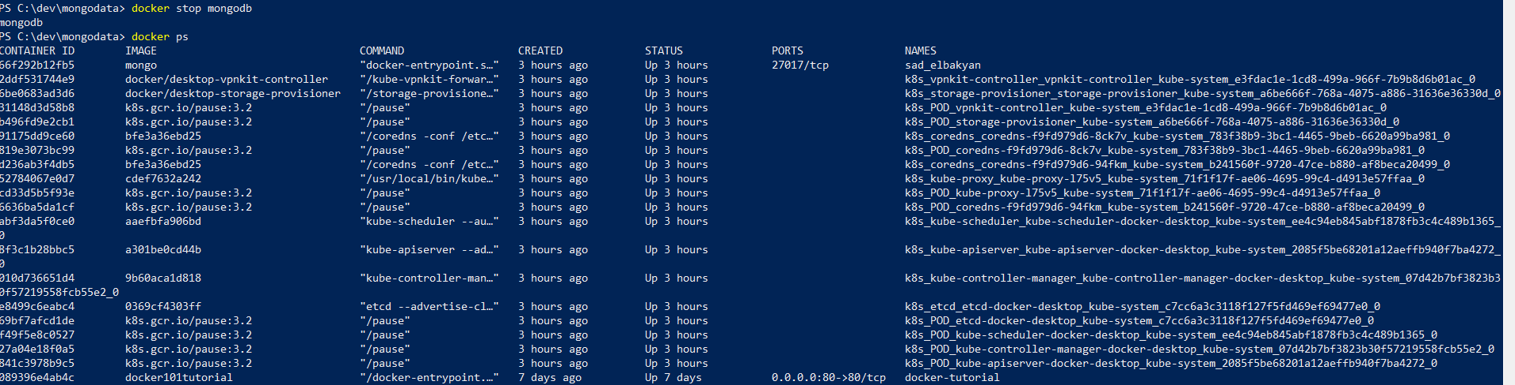

Containers are started by using the **docker start** command:

### You need to **Screen Capture** the output

**docker start mongodb**

4. The list of running containers now confirms that the MongoDB database has been initiated once again:

### You need to **Screen Capture** the output

**docker ps**

